EXPERIMENT – 1

Roll No : 2116240701179
Name : Harsan.J

USER INTERFACE AND DESIGN

BAD DESIGN :



GOOD DESIGN :

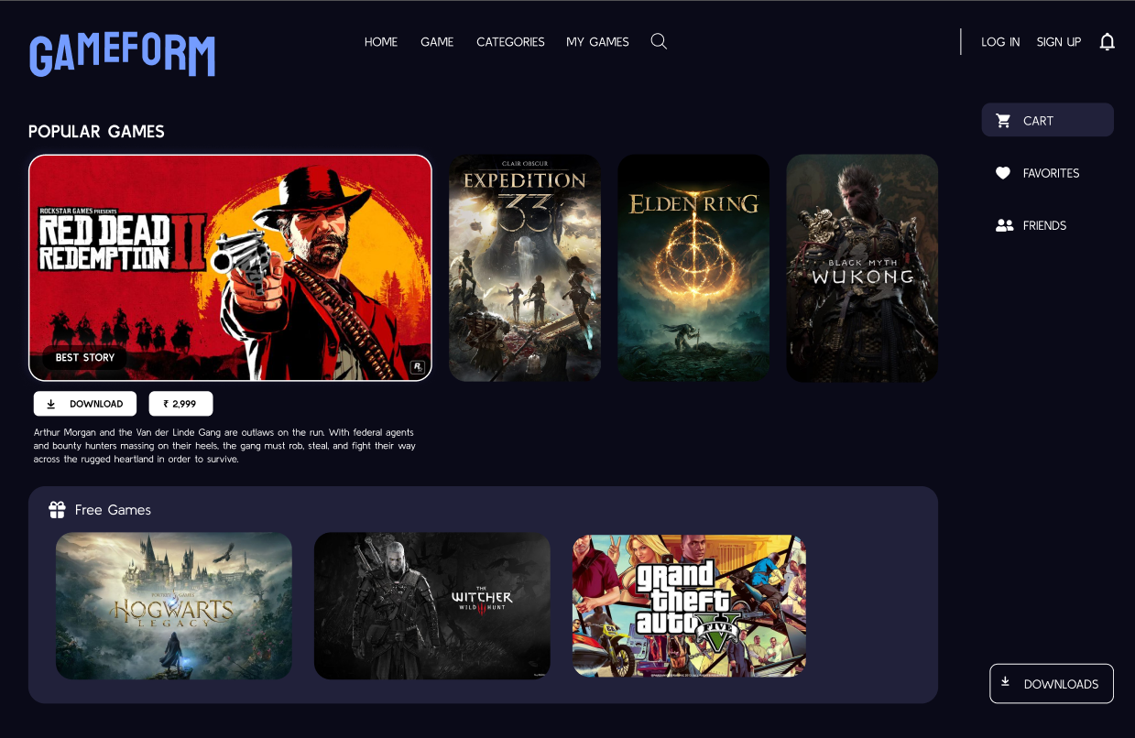

PROTOTYPE LINK :
https://www.figma.com/proto/UfcGtEnQceI3q94r5lucr7/Untitled?page-id=1%3A8&node-id=2-2&p=f&viewport=-1285%2C-1187%2C0.85&t=ZjmbEqhlgt0qq8Wt-1&scaling=scale-down&content-scaling=fixed

The two pictures have distinct designs and approaches
Here’s a comparison :

BAD DESIGN (First Image Reference)
The first image represents a poorly designed user interface., the overall layout lacks structure and visual appeal.
- The page uses excessive empty space, making the interface look unfinished and unengaging.
- Content hierarchy is weak; headings, images, and descriptions are not clearly prioritized.
- Navigation elements such as menu items and buttons are small and not visually distinct.
- The product image appears isolated without supporting visuals or background context.
- Typography lacks variation, reducing visual interest and brand impact.
- The design fails to guide the user’s attention, resulting in low user engagement.
Overall, this design focuses only on displaying information rather than creating an immersive or memorable user experience.

GOOD DESIGN (Second Image Reference)
The second image demonstrates a well-designed and visually appealing user interface that follows core UI and UX principles.
- A strong visual hierarchy is created using bold typography, high-quality images, and contrast.
- The color palette is consistent with the Ferrari brand, enhancing brand identity.
- High-resolution images are used effectively to attract attention and convey luxury.
- Content is well-aligned and structured, making the interface easy to scan and understand.
- Navigation is clearly visible and logically placed, improving usability.
- Text placement and spacing improve readability without overwhelming the user.
- The design emphasizes storytelling, emotion, and brand experience rather than just information.
This interface successfully balances aesthetics and functionality, offering a premium and engaging user experience.

COMPARATIVE ANALYSIS
Aspect | Bad Design | Good Design
Layout | Unstructured and minimal | Well-aligned and balanced
Visual Appeal | Plain and less engaging | Rich and immersive
Branding | Weak brand presence | Strong brand identity
User Experience | Low engagement | High engagement
Readability | Moderate | Excellent

CONCLUSION
From the comparison, it is clear that good UI design enhances user engagement, brand perception, and usability. While the first design only presents content, the second design creates an emotional connection with the user through visual storytelling and structured layout. Effective use of color, typography, images, and alignment plays a crucial role in successful UI design.

